|  |  |
| --- | --- |
| **Full Name** | **Muhammad Afzal** |
| **Batch** | **MS FSD DEC 2021 Cohort 1** |
| **Student ID** | **Afzal** |
| **Project Title** | **CI/CD Deployment for Springboot Application.** |
| **Project Submission Date** | **August 26, 2022** |

# Tools:

1. Eclipse
2. SQL Work Bench
3. Docker

# Other software and data manage tools

1. Spring Boot Dev tools
2. Mysql
3. Command Prompt

# Steps to Deploy the Project:

## Create a Spring Book Application

## Check the port in application.properties file

server.port=8094

## Update the application.properties from localhost to docker-mysql for the Jar file

spring.datasource.url=jdbc:mysql://docker-mysql:3306/schoolmanage

## Now create a Jar file using Run as Maven Build and Use Clean Install

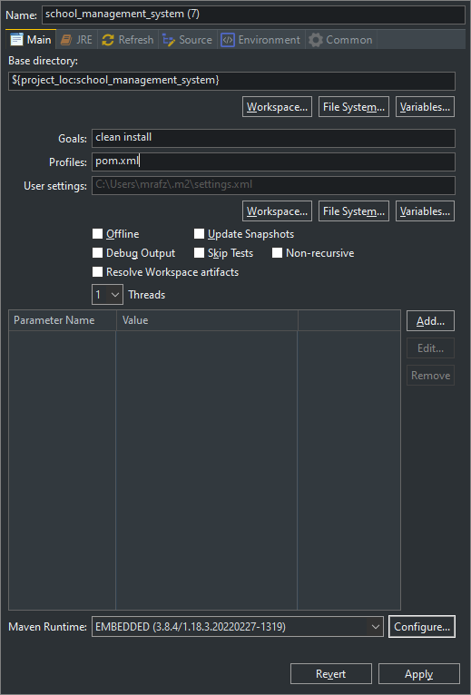

## Create Docker File and add Details for the Jar file and other data

From openjdk:17  
Expose 8094  
Add target/school_management_system-School-Version-1.0.jar school_management_system-School-Version-1.0.jar  
ENTRYPOINT ["java","-jar","/school_management_system-School-Version-1.0.jar"]

## Open CMD and Pull mysql

docker pull mysql:latest

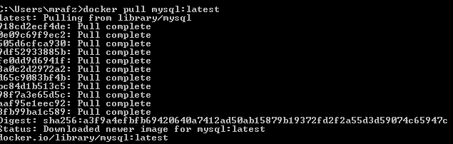

## Run image

docker run --name docker-mysql -e MYSQL_ROOT_PASSWORD=password -e MYSQL_DATABASE=schoolmanage -e MYSQL_USER=user -e MYSQL_PASSWORD=password -d mysql:latest --default-authentication-plugin=mysql_native_password

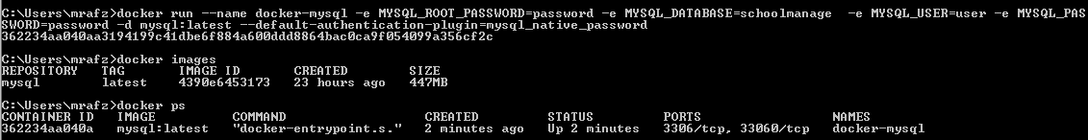

## Open Command Prompt in Project file Directory

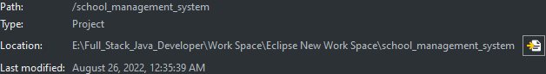

## Create an Image

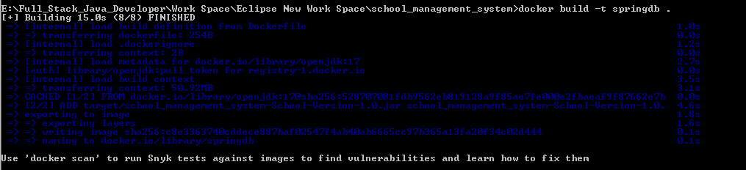

## Use Images and Run app on port 8094 port number mentioned in docker

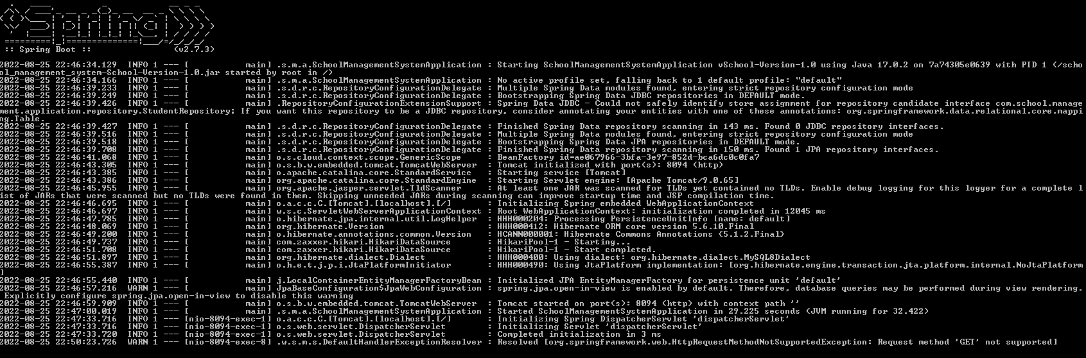

|  |
| --- |
| Main |
|  |
| Add New Student    Fetch all Student  Display All Student  Edit Update Student:  New Data  New Student Updated  Delete Student 5  Deleted Student |

**Thank you**